Writing 1 HOUR
TASK 01:
You should spend about 20 minutes on this task.
The chart below shows changes in three different areas of crime in Manchester city centre from 2003 to 2012. Summarise the information by selecting and report in the main features and make comparisons where relevant.
Write at least 150 words.
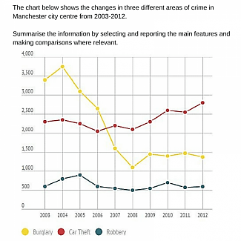
TASK 02:
You should spend about 40 minutes on this task.
The use of animals in entertainment, such as circuses and zoos, is a controversial issue. Some people argue that it is a harmless and enjoyable form of entertainment, while others believe it is cruel and unethical. Do you agree or disagree with the statement that the use of animals in entertainment should be banned?
Write at least 250 words.
Writing 1 HOUR
TASK 01:
You should spend about 20 minutes on this task.

Your city council is planning to pull down one of the historic buildings in your town because they do not have funds to renovate it. As a citizen, you do not want it to happen.
Write a letter to the city council. In your letter,
- say what the importance of this historic building is
- mention why it should be renovated rather than pull down
- suggest a plan to raise funds and maintain the building in the future

Write at least 150 words.
You do NOT need to write any addresses.
Begin your letter as follows:
Dear Sir or Madam,

TASK 02:
You should spend about 40 minutes on this task.
The use of animals in entertainment, such as circuses and zoos, is a controversial issue. Some people argue that it is a harmless and enjoyable form of entertainment, while others believe it is cruel and unethical. Do you agree or disagree with the statement that the use of animals in entertainment should be banned?
Write at least 250 words.

